

MOBILE WORLD

CHENNAI

TELECOM STORE INVENTORY

Software Requirements Specifications
Version 1.0



JANUARY,2014

Warning
This is a hard copy of a document maintained on electronic media. It may not be the latest version. Kindly ascertain the latest version from the Document Master List available with the Project Leader.

DOCUMENT RELEASE NOTICE

Document Details:

Name | Version No. | Description
Software Requirements Specifications | 1.0 | SRS document for the “Product, Stocks and Sales Promotion” module of the Telecom Store Inventory project of Mobile World

Revision Details

Action taken  (Add/Del/Change) | Preceding Page No. | New Page No. | Revision Description

This document and any revised pages are subject to document control. Please keep them up-to-date using the release notices from the distributor of the document.

Approved by: Date:

Authorised by: Date:

PREFACE

Purpose of this Document

This document describes the System Requirements Specifications of the Product, Stocks and Sales Promotion module of the Telecom Store Inventory project of Mobile World. This document lays down the software requirements for the application that have been captured through a detailed study of the business work-flow and functions.

Intended Audience

This document is intended for use by the designers of the system, and for those who may be required to maintain it. The document will enable them to understand all aspects of the system in detail. It will enable the client, “Mobile World” to know that TCS has captured all the requirements. The document will also be used by Mobile World for carrying out the acceptance testing for which it will form the written material of reference.

The intended audience of stakeholders for this specification of the TSI include:
- Administrator
- Inventory Manager
- Retailer

Related Documents / References

The following documents have been referred to for the preparation of this SRS document:

- Technical Proposal for the study
- Contract and associated relevant documents

Acronyms and Abbreviations

Abbreviation/Acronym | Description
TSI | Telecom Store Inventory
CSS | Cascading Style Sheet
JS | Java Script
HTML | HyperText Markup Language
JSP | Java Server Packages
SVN | Subversion Control System

Organization of this Document

This document consists of <X> sections and <X> appendices.

Section 1
Section 2

TABLE OF CONTENTS

1. Introduction 1
1.1 Background 1
1.2 Scope 1
1.3 Business Justification for Investment 1
1.4 Product Perspective 2
1.5 Key Assumptions, Dependencies, Constraints and Overriding Priorities 2
1.6 User Classes and Characteristics 3
1.7 Hardware and Software Platform 3
1.8 Site Adaptation 3
1.9 Application Security 3
1.10 Migration Requirements 3
2. Functional Requirements 4
2.1 Requirement 1 4
2.2 Requirement 2 4
2.3 Requirement 3 4
2.4 Requirement 4 4
2.5 Requirement 5 4
2.6 Requirement 6 4

3. User Interface Specifications 5
3.1 GUI Screen Layouts 5
3.1.1 Navigation Chart 5
3.1.2 Screen Layout : <Screen Title> 5
3.1.3 Screen Description 5
3.2 GUI Report Layouts 5
3.2.1 Report Layout 6
3.2.2 Report Description 6
4. External Interface Specifications 7
4.1 System Interfaces 7
4.2 Interface Descriptions 7
4.2.1 Message/Interface Specifications 7
5. Other Requirements 8
5.1 Generic Requirements 8
5.2 User Access Control and Security 8
5.3 Archiving and Housekeeping 8
5.4 Performance Requirements 9
6. Appendix A: Analysis Object Model 10
7. Glossary of Terms 11

Total Number of pages: 25

Introduction

Background
This document outlines the software requirement specification for the Product, Stocks and Sales Promotion module of the Telecom Store Inventory of Mobile World Application System. It is the outcome of the Analysis Phase during which discussions were held with the users. The objective of this Analysis Phase was to:
- Define the scope for the Product, Stocks and Sales Promotion system.
- Serve as the baseline for the design of the Product, Stocks and Sales Promotion system.
Any changes to requirements after acceptance of this document will be through appropriate Change Management procedure, as detailed in the contract.
Both the user and designer should go through the document carefully in order to ensure that:
- All the user requirements which need to be supported by the system have been identified and detailed.
- The document is a clear and unambiguous statement of functionality required from the system for the design and development team.
- The document can be used as a basis for development of the System Test data.
It is essential to identify the problems, if any, with the basic structure of the proposed system at this stage. If these are not taken care of at this stage, it may be difficult to incorporate the desired modifications to overcome the shortcomings at a later stage.
1.2 Scope

The scope of this undertaking is to design a system to maintains different kinds of product models in the inventory such as handsets, SIMs, accessories etc. The project should enable the Inventory manager to add the product model details, view stock details, status (Available/Allocated/Dispatched) and furthermore to allow the inventory manager to tag the product to the retailer as well as to generate complementary packages for the retailers.
This module is not explicitly responsible for providing functionalities related to the administrator or the retailer, but supports integration with external modules of the same.
The project will hence aim to provide an automated structure to the Telecom Store Inventory system, increasing the efficiency of business transactions.

Business Justification for Investment
The management of the concerned telecom store is an extremely important aspect of making sure that customers receive what they need, when they need it. Hence it is very important to maintain track of telecom equipment in the store to prevent disasters.
Customers can walk into a retail store and place orders. Therefore, all stock must be maintained up to date. But in an automated environment, customer places orders via a portal and the order is delivered at the address specified at the time of order placement. Hence the efficiency is increased.
The automated system will enable them to compete with the other similar enterprises.

Product Perspective
The TSI system is intended to be a stand-alone application and should not depend on the availability of any software, other than those included in the application package. This module is a part of a three module system of the TSI project. The other two modules include “Administrator” and “Order processing, Rewards and Defect tracking”.
The modules must work together to produce an automated inventory system. Functions such as viewing the system should run on both UNIX and Windows based platform. The portal should be user-friendly, quick to learn and reliable for the above purpose. In order to be able to integrate the module with the other modules, the UI styling should be flexible.

Key Assumptions, Dependencies, Constraints and Overriding Priorities
The successful execution of the assignment will depend on the following factors:
Assumptions:
- Inventory Manager will set the limits of threshold for each product.
- To remove a product model from the store the prerequisite is that no products of this model should be in 'Allocated' status and also there should be no retailers tagged to this product.
- Removing a product from the store does not remove the details of products which are delivered, from system.
- Retailer rewards will be processed and dispatched only after getting acknowledgment from customer, about the successful product delivery
Dependencies:
- Involvement of the end users in signing off this SRS document.
- Availability of System Software from the client for development.
- Availability of installed hardware/System software for implementation.
- Feedback on this report will be provided as per the agreement in the contract. Any delay in the feedback will have impact on the schedule and cost of the project.
Constraints:
This module uses no constraints while defining the Functional Requirements and system behavior.

User Classes and Characteristics
User Class 1: The Inventory Manager:
The inventory manager user this module as a portal for performing operations such as adding products, viewing stock lists, configuring packages and to tag products to retailers. There may be more than one inventory manager with simultaneous access to the system. They form the primary user class of this module.
User Class 2: The Super Admin:
The super admin is primarily associated with the “administrator” module and may also choose to access the inventory manager module. The super admin also has access to all other modules.

Hardware and Software Platform
Hardware:
Processor : Pentium IV processor (minimum)
Memory : 256 MB RAM (minimum)
Disk space : 250 MB of free space (minimum)
Software:
Frontend : HTML
Business Logic : JSP, JAVA Servlet
Web Server : Apache Tomcat Server 7.0.37
Backend : Oracle 10g
Scripting language : JavaScript
Java IDE : Eclipse Galileo

Site Adaptation
Not Applicable.

Application Security
The project is developed under the security constraints maintained by TCS, which take into consideration, all confidentiality agreements and non-disclosure agreements wherever applicable.

Migration Requirements
Not Applicable.

Functional Requirements
This project module is designed to be used by the inventory managers. It is responsible for the following functionalities.
- To log into the module
- To add product details
- To maintain stock list
- To tag products to the retailers.
- To offer complementary packages to the retailers.
- To log out of the module

Functional Requirement 1
Title: Logging into the inventory manager module
Description: Login details and password are provided by the administrator module. Administrator also provides a login page, where the credentials are authenticated, in order to access the inventory manager pages.

Functional Requirement 2
Title: Adding Product Details
Description: In the homepage there is an option to add product details. When it is selected, it prompts the inventory manager to add details. The details are validated in proper format using JS functions .The details are sent to the server and stored in the appropriate table.

Functional Requirement 3
Title: Maintaining Stock List
Description: In the homepage there is an option to view the stock list. The stock list shows the Threshold limits of the various products and the retailers tagged to it. There is also an option to sort the stocks based upon the status.

Functional Requirement 4
Title: Tagging products to the retailers
Description: While adding the product details, the Inventory Manager can tag the products to the retailers. The Inventory manager will use the retailer ID provided by the admin to tag products.

Functional Requirement 5
Title: Configuring Complementary Packages
Description: In order to promote sales, The Inventory Manager can offer complementary packages to the retailers who place maximum order. Packages are defined in the database table with Package Id referring to the Complementary Offers.

Functional Requirement 6
Title: Logging out of the inventory manager module
Description: Using the logout button, the session can be terminated.

User Interface Specifications
The interface shall consist of a home page, where the links to all other screens will be present. The following links would be available at the home page.
- Add Product Details
- View Stock List
- Tagging products to retailers
- Complimentary packages
A log-in page shall be provided, where the inventory manager must provide user-name and password authentication to be able to access the home page. At each further link, inclusive of the home page, a logout link shall be made available.
At the “Add Products” screen, suitable text boxes, radio buttons, date-pickers and drop-down lists shall be provided, in order to obtain required inputs from the inventory manager. A button for submitting the details shall be added. On submission, the details will be added to a new entry in the corresponding table.
At the “View Stock List” screen, a table consisting of all stock details, including status shall be available. Options for sorting the stock list shall also be provided.
At the “Tagging Products to Retailer screen”, options will be present to tag available retailers to available products. The list of retailers and products will be imported from the appropriate tables.
At the “Complimentary Packages” screen, option will be provided to configure complimentary packages and to issue the packages to retailers.

GUI Screen Layouts
The standard layout of the user interface is specified in this section. The interface consists of a header with the company logo and title, as well as a footer with notes and copyright details.
Details corresponding to the individual pages are included in the divisions in between them. A common style sheet is provided to have a uniform layout throughout the interface.
3.1.1 Navigation Chart
<A navigation chart showing the access routes to the screens should be included. A high-level chart can be produced and decomposed to the number of detail levels required.>

Screen Layout : <Screen Title>
<The screen layout should be included; a bitmap may be used where available.>

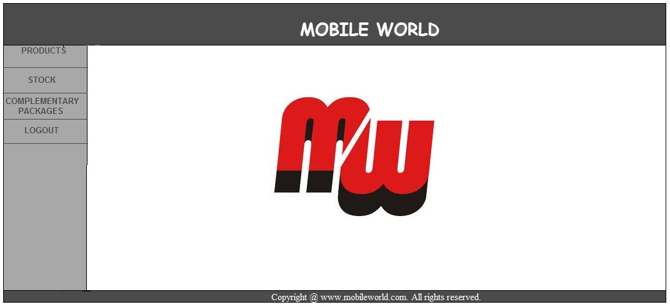
Fig. 1.0 Home page

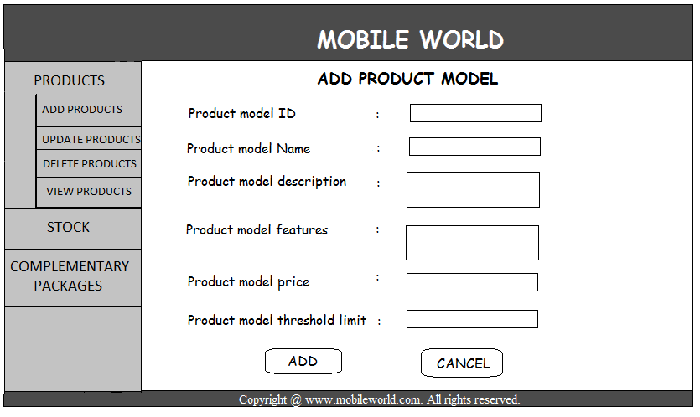
Fig. 1.1 Add product models

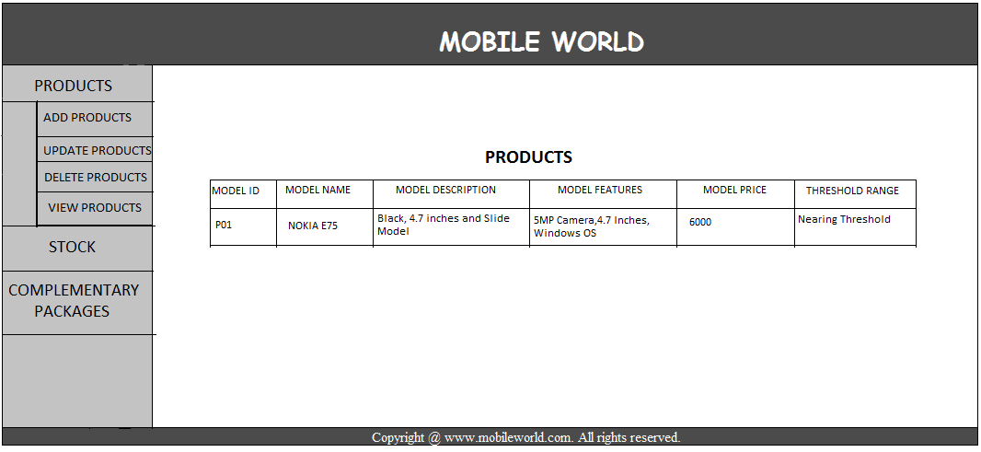
Fig. 1.2 View product models

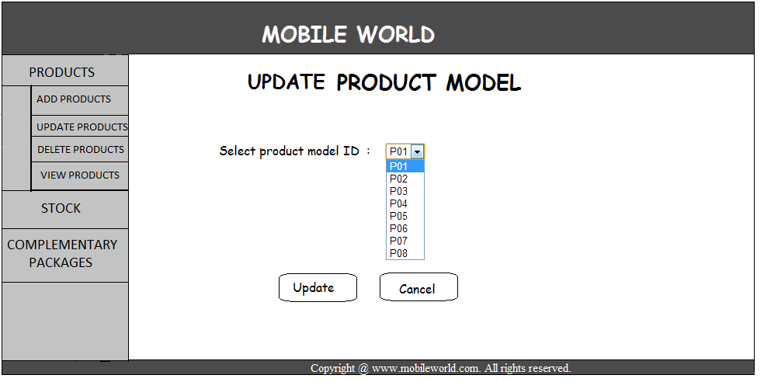
Fig. 1.3 Select existing product model ID to update

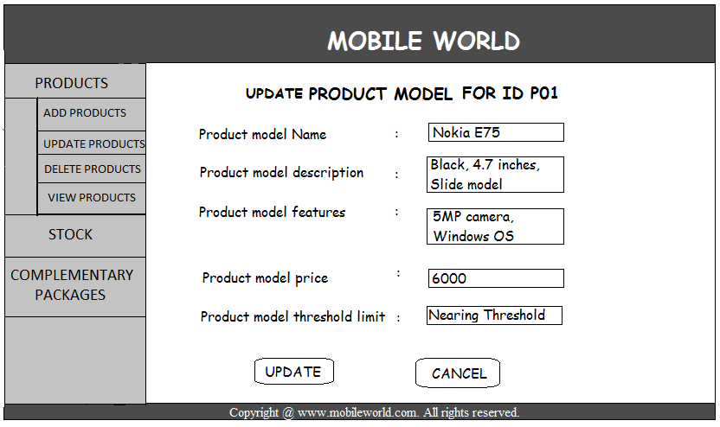
Fig. 1.4 Update product details

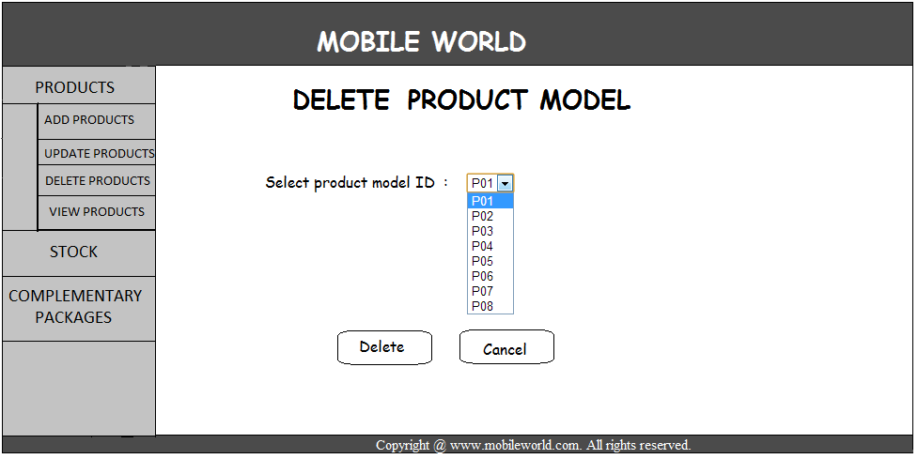
Fig. 1.5 Select existing product model ID to delete

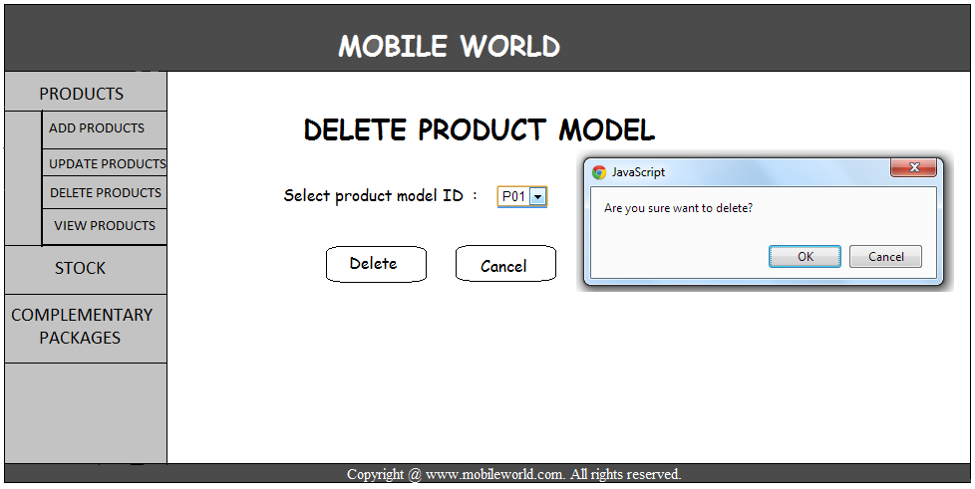
Fig. 1.6 Confirm delete product model

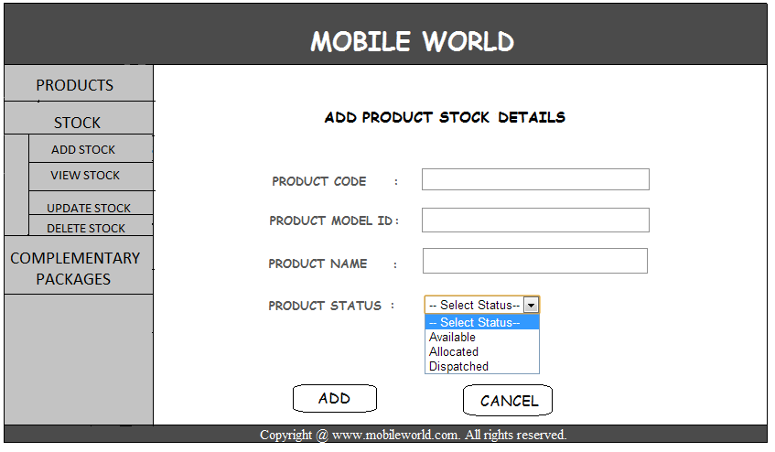
Fig. 1.7 Add stock details

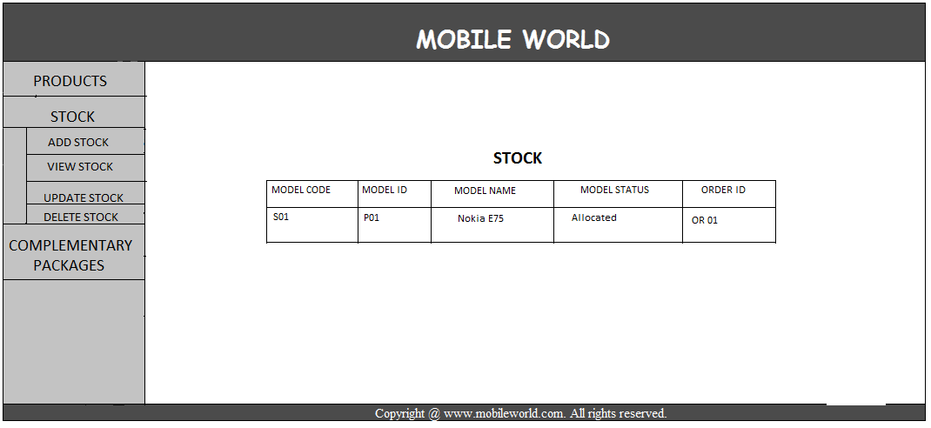
Fig. 1.8 View stock details

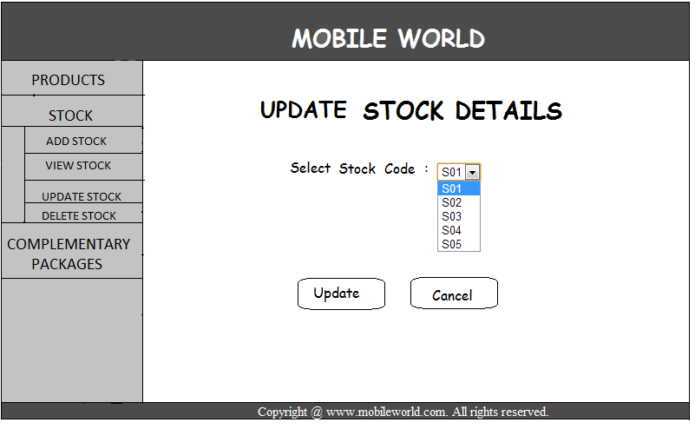
Fig. 1.9 Select existing stock code to update

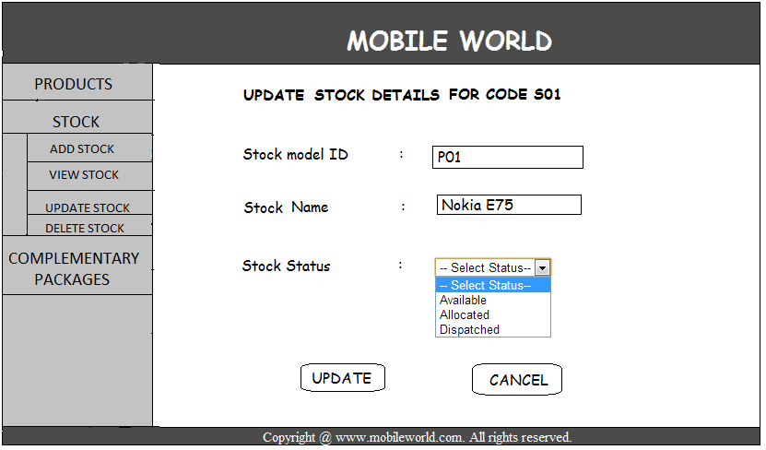
Fig. 1.10 Update stock details

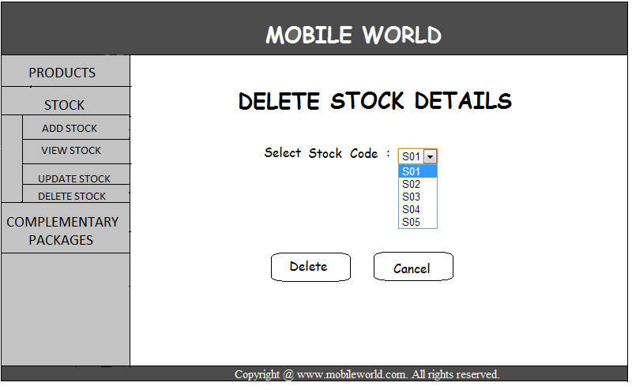
Fig. 1.11 Select stock code to delete

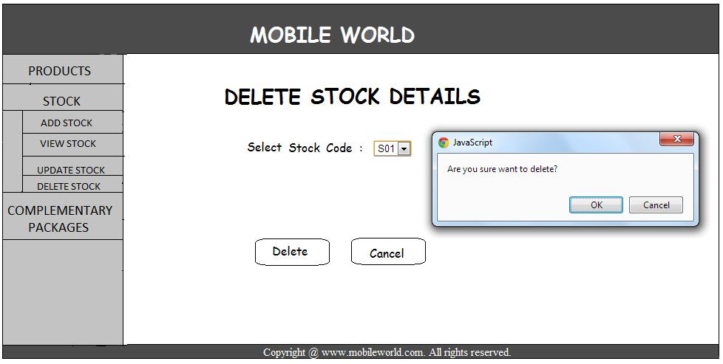
Fig. 1.12 Confirm to delete stock details

Screen Description
<Each screen layout should have an accompanying narrative. a.
<Details of the screen may be given in the following format:>

Attribute Name | Description | Remarks

GUI Report Layouts
<Give a brief description of the sub-section>

Report Layout
Not Applicable

Report Description
Not Applicable

External Interface Specifications
The TSI system is a standalone application. It does not require interaction with any external interfaces.
  - System Interfaces
Not Applicable
4.2 Interface Descriptions
Not Applicable
4.2.1 Message/Interface Specifications
Not Applicable

Other Requirements

Generic Requirements
Not Applicable

User Access Control and Security
Operating System Level
Each user shall be assigned a separate log-in Id and password. These may be divided into three groups.
Application User: This may have access to Application software only. These users may not have any access to the Operating System commands outside of Application Menus
Operating System User: This user may have access to user level Operating System commands in addition to the Application software and certain RDBMS tools
Super User may have access to all the commands, including super user commands, at Operating System level apart from the above two.
Besides above each user will be assigned a user code at the time of implementation of the system. It will be possible to set or change the password interactively. Each user or group of users will have access to certain screens/functions of the system relevant to his area of operation. The access rights for each user code will be recorded within the system. Each user will have to log-on to the system using the correct user code and password. In case of an invalid combination of these two codes, the system will display an error message and prevent further processing.>

Archiving and Housekeeping
<Provisions may be made at the following levels by dividing the users into following groups, user interface for which may be provided.
Database Administrator (DBA) may own the database. These users may create, update and drop database objects, namely, table-spaces, tables and indexes etc.. The maintenance of the access rights may be done by them. Only they may have access to the security / access maintenance screens. Any modifications to the access rights may be made only with proper authorization. They may be responsible for overall maintenance and management of the RDBMS.
System Administrator (SYSADMIN) may own the application. It may create, update and drop users, user groups for the application and provide required access to them.

Performance Requirements
<Describe the ‘system availability’ requirements and the system performance requirements (e.g. response times and capacity) in critical areas of the system, and the envisaged system workload patterns and peak activity.>

Appendix A: Analysis Object Model
<This section presents a list of the fundamental objects that must be modeled within the system to satisfy its requirements. The purpose is to provide an alternative, "structural" view on the requirements stated above and how they might be satisfied in the system.

The RSI (Requirement/Services/Interfaces) approach should be taken for use case analysis of the system. This approach provides a framework for analysing and understanding potential use case deliverables and their inter-relationships. It also provides a framework for decision making on the appropriate "granularity" and "content" of use cases. The requirement use case should be defined at this stage in the format mentioned below. During the design process, the requirement use cases should be extended and based on it Service and Interface use case categories can be defined.

From a process perspective, two phases of use case analysis emerge: high level «requirement» use case gathering and detailed «service» and «interface» use case specification. «service» and «interface» use case definition are undertaken in parallel, as «interface» use cases drive the definition of the set of «query service» necessary in the system.

«Requirement» use cases document business processes for which automated support may be required. They detail the requirements driving the development of a system, but do not define the detail of a system's functionality. «interface» use cases provide a detailed description of the interfaces presented to the system's actors and association functionality. «service» use cases provide a detailed description of the underlying functionality a system offers in a manner independent of the needs of any particular interface.

The Analysis Object Model (AOM) will contain the following:

- Use Case View:

- Use Case diagram
- Activity Diagram to realize Business use cases

- Analysis View:

- Class diagram
- State transition diagram (If classes need to store state information, more pertinent for Embedded systems application)
- Sequence diagram (or) Collaboration diagram.>

AOM will be done using a tool supporting UML notation, like Rational Rose.

Glossary of Terms
<All the terms used in the application must be defined in a clear manner in the glossary. The objective of this is to have in one place common and clear definitions of all the terms. In addition the glossary must contain the list of allowed values for the term in one place>

